Please shred and incinerate this document after use!
Hello agent Decader, please call me when you are securely in position at the designated hideout.
We have, with our advanced telecommunications technology, made it possible to operate exactly one phone call without being tapped. Your phone number will be exposed after our initial call. Please call me when you are ready, and I will brief you on your mission.
Call BLackout-8842 exactly once, that’s BL-8842
Be weary that all long-distance phone calls are being listened to by operators.
According to our intelligence, the bunker is equipped with a telephone, an FM radio, a telegraph key, and a radiofacsimile receiver.
Regards. Blackout


KNOWN PEOPLE & AGENTS

Image Missing

Heinrich Müller
High ranking German officer involved in project x. He is very cautious, decoding information from him will be tough.


Image Missing

Agent Gerald Freeman. Aka. Rudolf Schmidt
This American-German spy is a skillful agent that has worked with us for many years that spy. Although intelligence suggests he might be a double spy working for .

Image Missing

Sergei Mikhailov
Sergei is a valuable cooperating Soviet intelligence officer, we’re however afraid the soviets might be keeping certain intelligence hidden
INTERNATIONAL MORSE CODE
.  short signal | -  long signal

E |  |  |  |  |  |  |  |  |  |  |  |  |  |  |  | T
I |  |  |  |  |  |  |  | A |  |  |  |  |  |  |  | N |  |  |  |  |  |  |  | M
S |  |  |  | U |  |  |  | R |  |  |  | W |  |  |  | D |  |  |  | K |  |  |  | G |  |  |  | O
H |  | V |  | F |  | Ü |  | L |  | Ä |  | P |  | J |  | B |  | X |  | C |  | Y |  | Z |  | Q |  | Ö
5 | 4 |  | 3 |  |  |  | 2 |  |  |  |  |  |  |  | l | 6 |  |  |  |  |  |  |  | 7 |  |  |  | 8 |  | 9 | O

l •----
2 ••---
3 •••--
4 ••••-
5 •••••
6 -••••
7 --•••
8 ---••
9 ----•
O -----
In case you stumble upon German handwriting, it might be good for you to know how it looks
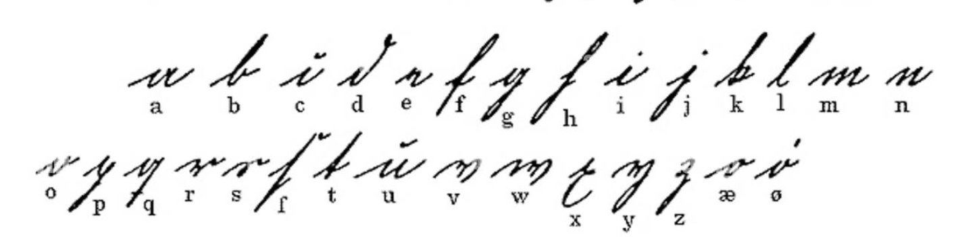
Gameplay Controls:
Switch between tools – right and left d-pad

Phone:
Pick up phone – d-pad up
Dial number – crank

Radio:
Select Frequency – crank
Listen – A

Morse Key:
Signal – a or d-pad down

Radio Fax:
View Received Document - hold A

Safe:
Well. How does a rotary combination lock work?

Window:
Look around
Hints
Can’t seem to call Blackout?
Where coud BL be on the phone?

Don’t get the first hint?
Well, it is for the more telegraphically inclined.

“I can’t remember any of the phone numbers”
Blackout warned you, write everything down, there might not be anything left to do

I don’t know what to do with the safe
You’ll figure it out.

